**CPS Lab 4: Communications**

**I2C Communications (between two Arduinos)**

* Work with your friend
* Try the sketches from the links below with two Arduinos

<https://docs.arduino.cc/learn/communication/wire#tutorials>

* Create two sketches for two Arduino boards to do the following tasks

**Slave Arduino**

* + Connect a potentiometer to one of the analog inputs of this slave Arduino board.
  + Send the value of the potentiometer to the master whenever it is requested.

**Master Arduino**

* + Connect two LEDs with different colors (red and green) to two digital outputs of this master Arduino board. (don’t forget to use resistors)
  + Receive the value of the potentiometer from the slave Arduino every 5 seconds.
  + Check the received value and if above half or one specified value, turn on the red LED; otherwise turn on the green LED.
* Demonstrate your work to Instructor or TAs.
* Submit your code and the photo of your circuit.

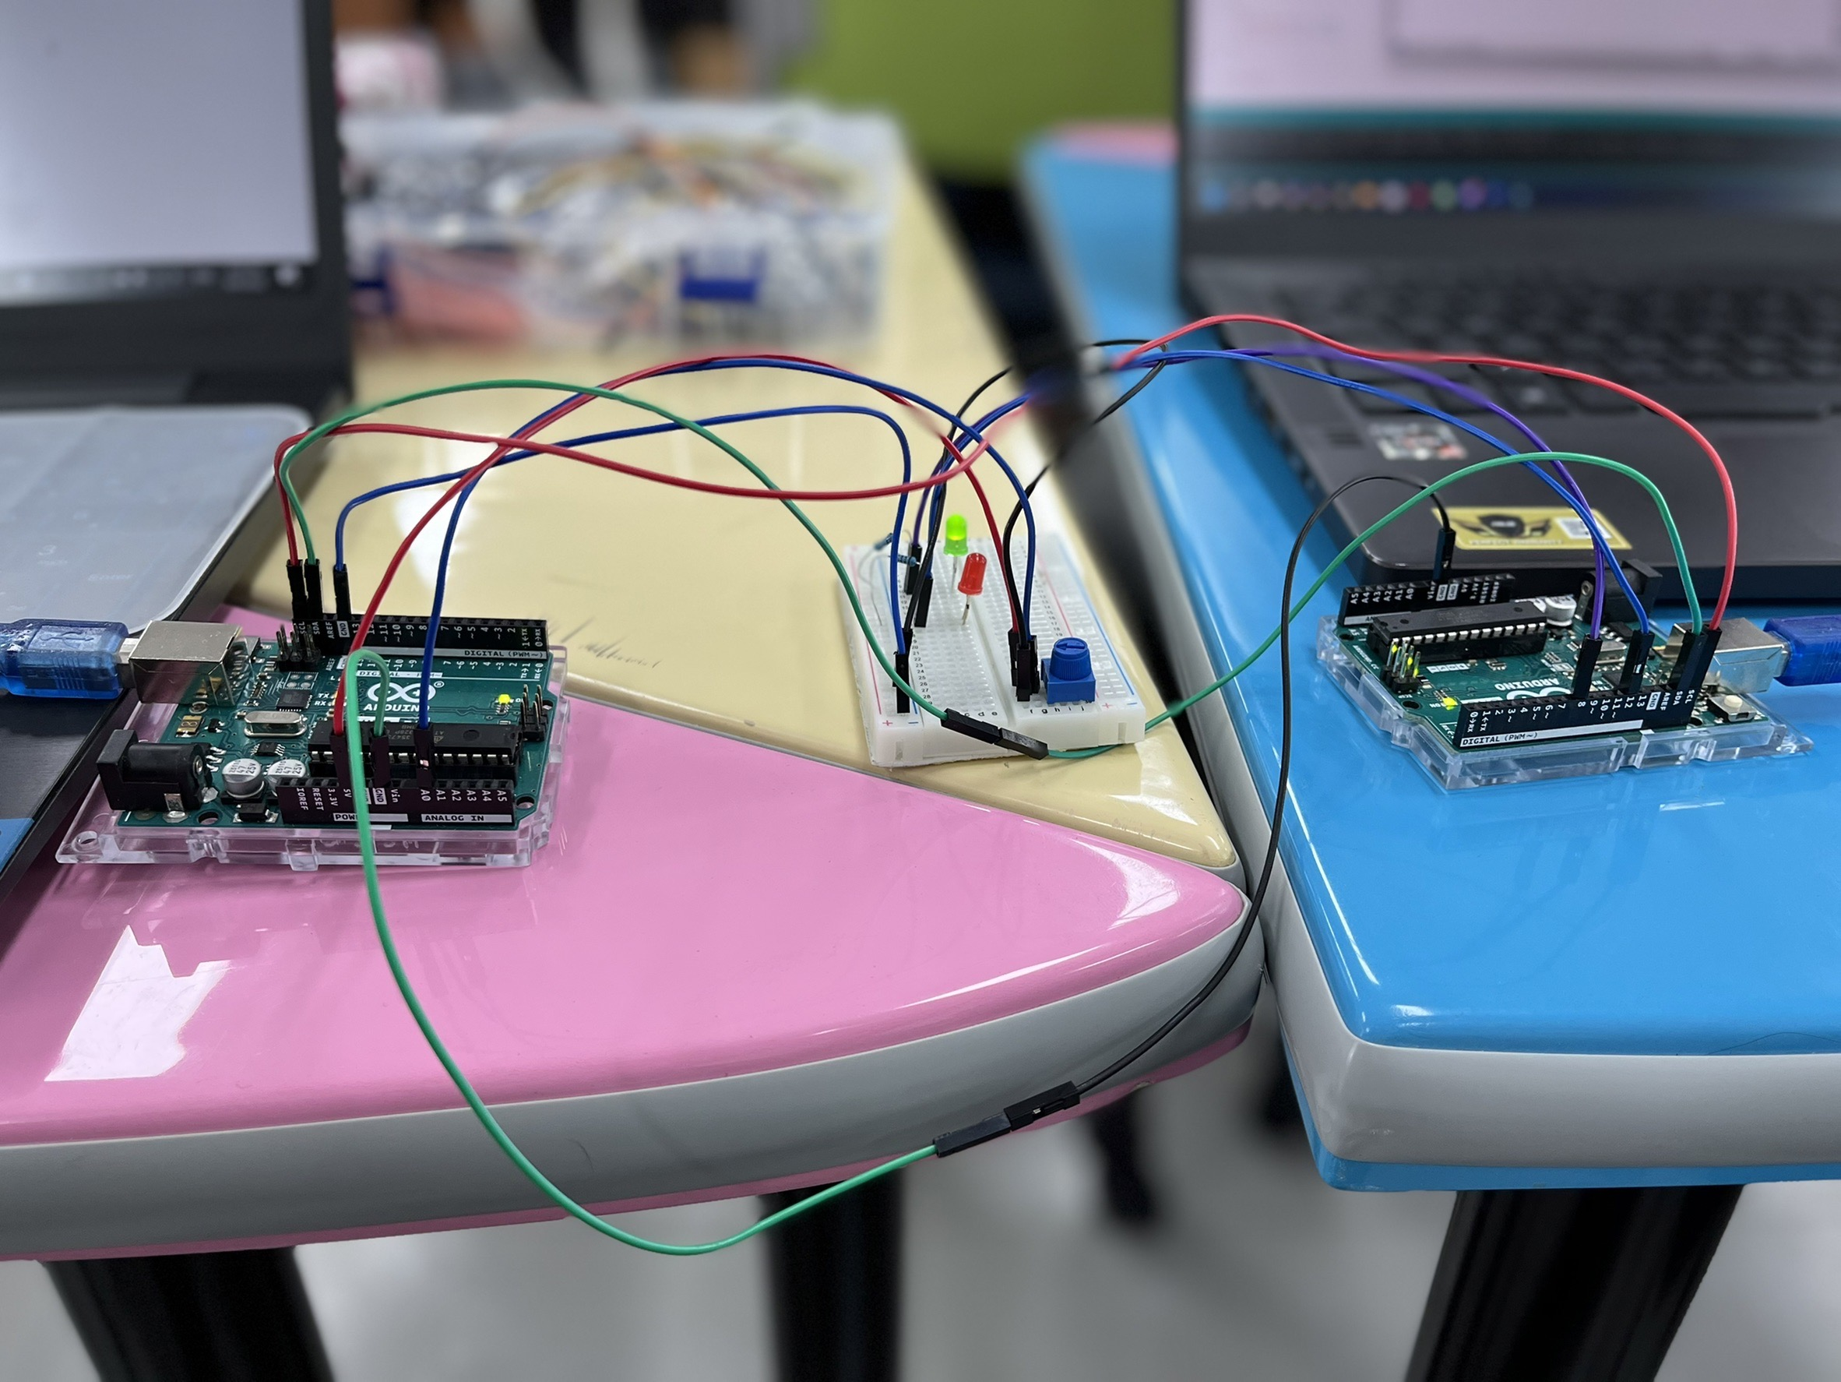

Reference:

<https://www.arduino.cc/en/reference/wire>

<https://docs.arduino.cc/library-examples/>